Dear Glenn
_{o}k 4_ )₁1)__C
I1 .A4

I am following your family Blog with great interest.
I was in the vicinity of Dinton one day last week and decided to stop by Dinton parish
church and explore a little. The church itself was closed therefore, when you visit in
August it might be wise before you visit Dinton to request the church be open when you
are there. I will e-mail the Vicar a few weeks beforehand and ask if this can be done, so
that we can see the monuments inside.
I took a few photographs and have attached the best. I don't mind if you wish to use one
on your Blog. The first is the medieval porch (twelfth century) on the south side of the
church, not the west doorway you can see in the other pictures. The view from the
church itself is amazing, across the green fields of the Aylesbury Vale and to the
Chiltern Hills. The tops of the houses in the photos are the old village of Dinton. Dinton
is a village full of quaint old cottages and is also worth a visit. The hamlet of Moreton in
Dinton, where the LEES lived is long gone. It is now classed as a deserted medieval
village, but from the earthworks that are left, the archaeologists suggest the Manor
House was one surrounded by a moat. As you know, by the end seventeenth century
the LEES seem to have disappeared from Moreton in Dinton and are resident in
Hartwell.
The house next to the church in the photos is Dinton Hall but this is not where the LEES
lived. The LEE's Manor House at Moreton was about 1¹/₂ miles south east of Dinton.
Notes by the Bucks Archaeological Society suggest there may be some old maps that
show the moated homestead with buildings inside. Articles on Moreton and Dinton that
you may find of interest, re Dinton are: httL,
history.ac.uk/report.aspx?compid=6:2771&strquery=LE and httryitwvim., brit,(7n_
history.ac.uk/report.aspx?compid=1210K and
https://ubp.buckscc.gov.uk/SincleResult.aspx?uid=TBC352 and also re- Moreton Manor
https://ubp.buckscc.gov.uk/SingleResult.aspx?uid=MBC1068
Finally, there is a correction to the list of Eleanor LEES children recently sent, and that
is the marriage of daughter Elizabeth. Elizabeth LEE married John DUNCOMBE in 1611
and not John DUNCAN as previously stated.
I hope the information helps.
Kind Regards
P.S. Finally, managed to upload another post Life on the farm in the sixteenth century:
part 1 to my own Blog Hopefully, the third will follow soon. I
have a particular interest in the HAMPDEN family as they were very involved in the

history of the village of where I live so, in due course there may be some posts on the
LEES and HAMPDENS.

13
0
cp
ct-
',4
0
C)
C
O
O
ni
r+.
z
0
CD
•••‘
Cv
CD
Wl3SfW AIN1100 3HIHSVIVH9NI>10118

\-71
* •
:⁷'OO
- 9
- CA
c+
a• 0
P
1--¹• O
CA P
ct- c+
H. 0 `•
^{c}-<
zz'4
M 0 0
¹•⁴3
c+
P
P. 0
'•4 c+
0 0 ('D
ed O c+
G 0 0 (D
cn • •
•
- s.
- O co
CA C+
- 0 CD
fti ₀ 0 CD ₀ M
¹1 pu
0 rt- •
1.5n 0 H•
N.4 P Cl) 0
- cy'
1—) Cr CD
ze• C-4 CD PJ
(n ct to
- a) (t)
- ct
- c+
H 0 '1
co 0 AP
P. P.+ c+
o
- c+ P HJ
- ern
CD
- C+ H•
CD
H• IZZ)
P. 0
c+
U) Cl)
- c+
P
₃:1
kJ, c+ P ••• • CD c+
C)
CD 0
0
e•4

- . •
'Stop 9 9 0 9 P o ^{i}"^{:3}
P O P ^{ca}"ri p., p co
- N ' ⁽¹⁾ 1 '1 c:t
cn ¹⁻O t—b
CD P COP. Cr
" *⁻⁴4 H. t,'"` p
CO c+ PP 9 0ti '1
!_⁻4 ca c+
\...r4 p o
P 0 ft ft
CA Cl) 0 Cl) p ^{f}'S
O G H• :3 0 O'N
- 0 cn 0 F•J• P.
PI 0 0 P
Cn .• • 0
" • H•t/ c+ 0 0^{0 P} 0 1 0
1
O •009
¹1 co CN CA CD 0
c+ ⁾⁻eJ c+ t.< p al ci2 ¹•⁴3
P
- 0 0 0 0 t.⁻5
1--¹• ¹⁻t 0 < I-fj 0
et⁻ c+ ct⁻ ed 3' c+ ^{O} CA 0 0 (.+
0 P• O
co En P' ⁽¹)
cs- Cr 0 PI
1"" P O 20 `• c•
- O 0 G t⁻⁻3
H. P• fl P 0
- PPcpc+'180
cm a o p
c+ O c+ Co
fe¹4 P. P.
H. 0 0 P• PJ O PJ
- CD H'
P
RC' C+ C+ PCJ c^{C}U
CD 0
- a 0 ₀ H,
00P
n: cn
P. 5 0
ct 0 P. 1-43 'CI
- ctf z P
N• Ca ⁽.71 C) c+
c+ 0 cf⁻
HJ 0 0
0 O
0 '-;1°4
- HJ C c+ H• C+ ll
(D H'•0 H•
Co Ce) P.' CD CA
- cD 0 c+ 0
H• P.
P
co
P C^{O}D • ^{cn}
0
- t:J
HJ c o (+N P.
¹⁻⁴D O C.C410

P• ct⁻ < 0
- o
"o f--⁾ CD •
W •
Cl) c+ 0 Cn c+ •
H• , 0
- co •••••
- Hi t-4 o
Cn oo ⁰ ⁰
s. O
Ca
cr. H•
'D Cn
p
⁻17
CD
¹⁷¹ •
0
u
tx1
00Hy^{cp}
Mr?.
e 0
'TT
1-4
CD

o
O
O
- •
Cl
0w
cf 0
II
CD S
Cr)

- CA
¹1 H.
CD P,
ct⁻
0
- 0
CD
papniouT uaaa
uopRooi luasam
CD
0

0
0
-h
Cf⁾.
CD
O
0
CD
C)

N • • •
00 :⁻Ft' 5'
cc) 1-⁶ O H• 0' 0
0 PI ₀
c+ o o c+
c+ 0 c+ 0 _{cn}
op 0 • w• 's_'cp
CD

- -k
- •
ct• • P H• -n
- ¹1 ₅.
t-b ₍-₁₎
cn a.
Pc, 0 C/1
- O cf ;⁹1
P 0 "«
¹1 ¹1
- ^{t}• '< •
•
0
/⁻⁴3
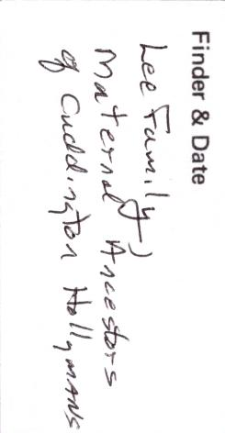
jo q.s TT paTmiouT
sear' egg jo

tr T.17TAA p a q..ung. T s
- q.T apTsq.no
- saoTjjo uaom-atiiTq
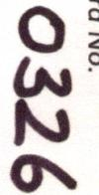

•
0)

5¹⁾

CO
Lrt
O
•
CD
0
0
O
¹⁻b
0
CD
¹⁻⁴a
•
H
k.Js1
0
0
r--1
3 0 Cr\ VI
0 e •
- c+ bj
is° • txi CI
- txj
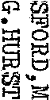
4 • •
tj •
ta
CD 0
- e-
c÷
CD CA
- CA
H
1
0
CD
PitTJ
1--h.
tD 0
1-³¹
-•
ca
O
O
O
O
:M°1A1°(1110Balillia

(Few eansoioua uowTa vc
e5z1,°c¹ ' 1 ;N011a °IT
UOR8111.10J.U1 10 Seal r1OS
of the Hundred. of Desborough
°94zed ^{c}z SMOn
0  0  N▪ D | 0  N▪ 3 | z

uoileooi luasaid
⁻0
CD
O
a.
C1)
N71•

33

adAl loafgo JO OUS
HSV\IVH9N
Wl3SfV A1NflO3
- •
(;)
C)
O 1-1
¹⁻t H•
(.÷
a\ 1.i.
aN 0
LQ_{J}
•
Ii
(t)
S‘o
0
c+
9`⁾
C)
•
O
C.1 I
&
•
Please list all sources of information overleaf.
- • CA
.
O c+ cn Fla H. E:).₀
0 • O G c+ P 0
rip ce cn•a.
(₁) • \D ca (1) 0 ¹1 c+ • z
0
- H.
ro N
c'D H• H• 0 ID P '1 7 c/J.
0 (r) ₍st
CD }-¹ Cn P H. 0
H• P H. 0 Pi °
40 "
C)II o H c+
t• `O Pi 0 0 ⁰
H. • 0 U1 CO )⁻⁴)
Cn O cD O • • ,(¹⁾
0 0 s,-4
c+ • ¹⁻t p • c+ CD a)
H• c+ p (i)
1—) co
;0 • wat;_{I}
(E) • H. c+
0 Pi Rom < H•
a) c+ O 0
CD H. n
_{(t)} ^{F}l c+
F—
c+ P H. H.
--C)coi⁻bvic(c)(34)
O j =Z-* •
o •K < HoC)
- c+ H. H. CA
rcn, frb O O ?„.30
ci; 0 •
ga (1) F-
r txi • a) O o
0 H.
Cl) 0 a' • ' ^{P} I O H.
H• 0 O cD 0
Cs P
(D • 'dc+
- a"⁻ci ¹⁻3
⁻(1)PcD(D
MI (D
c+ c+ <
O ET/ c+ H.
txj H. P
u) 0 0 c+ cD
ct•
0 pa' 014 Cn 0
Co G O hd
Q⁻1 H. ^{0.-}DcD
x⁻JS P
p_ • a, c+ ^{—.I}
p
ct cD Pi pi OO
c+ cD P⁻1 pi 0 c+
P Cl) H. ¹⁻d Co c+
ci) p c-t-
1--,pc4
⁰ 0)-¹
PI 0 et En H•0
CD Pi 0 P
(D Rc. H.
H. H.
`.< O cn
Q, • 0 Co
(D CD 00P0
UCJ) `I
0 c+ p o H.
Hc-t-0ct)P00
"I P
(J) pi CY¹ O i-¹
^{O}
0 1-J• co P.
PJ P cn 0 cn
- a) CT F-b
a)
a
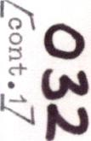
O
O
Cr\
a'
0 c+ a) 0 c+ o
- ... z '1
o• n
0., ₄,
- ..1) C⁻4"

`6-21..c07 sTaTad
c-i-
•
•
•

0 ⁻N. o
•••
a
a 14
o
0 tt.
1-₄
td
0 0⁻
tj
0 0
Ft 0
1-³ ct•
CD CD
Pi
H
H
CD
Uct
to
Ys
&
Pb^{tD}
CD
¹:D
CO
e-N.
CO
5'
Fh
H
CD
0
0
•
03
•
0
CD
cal
1-⁴
OIL2
/-r•
0
b
_Cu^{H}
ti•
CD
0
&
0
c+
CD
0
¹⁻f3
0
El*
CD
0
cfi
to
lay
F
₋f) 0
0 w
a
Ca
0
A
CD
tea
0
3*
-ps
⁹,
co
0
r+.
0 CDco
a
/A 0.SoRecord Cards (filed*).
CD
CD
H
113
rn
0
cri
•
.(7f
- •

fro',
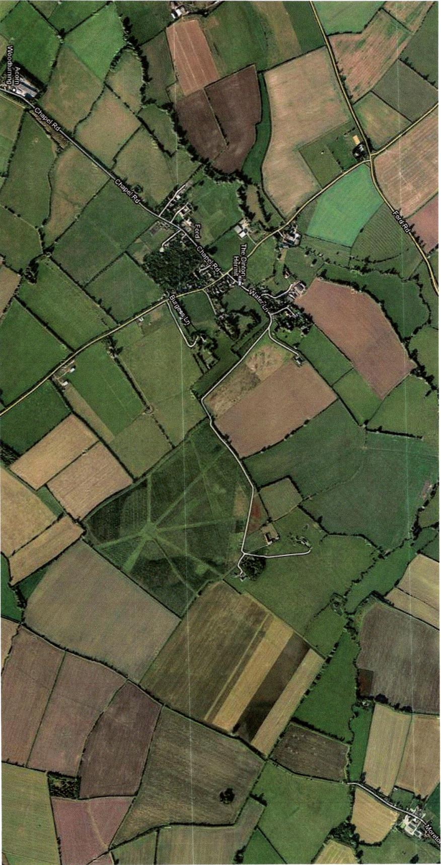

0
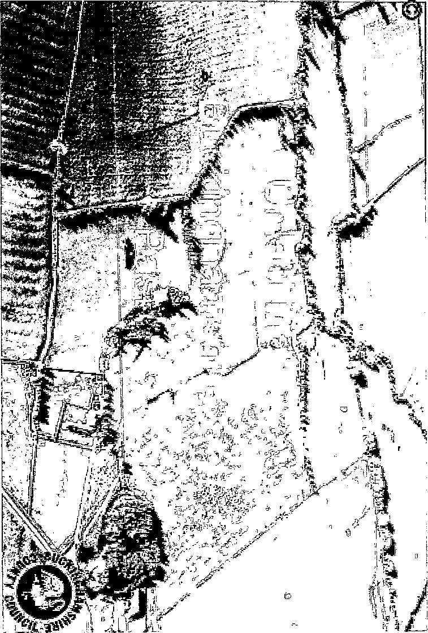
0 1
r
F

0

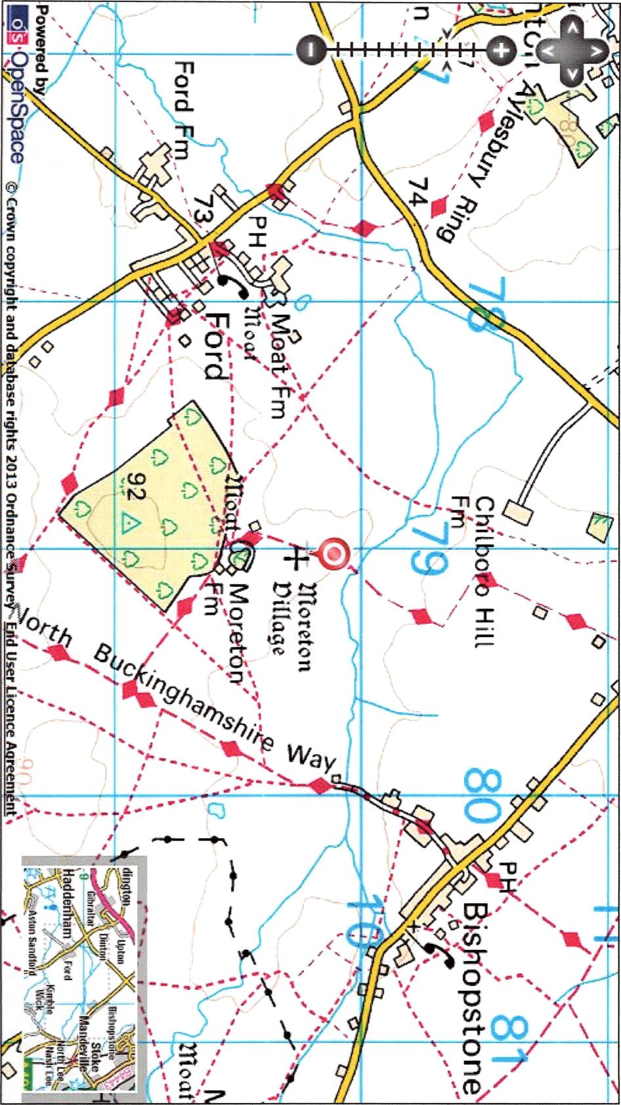
/Th

29
Thomas HOLLYMAN owned the lease on the Blue Boar not actually the Blue Boar itself. In
174777selling on, oi'^{--n--.4}=1r77M==MII^{-,}C.'moverall landlord at that time was the
Lord of Cauldwell Manor, possibly John LEIGH. Also Cauldwell Street was actually part of the
parish of Bedford St. Mary. The Blue Boar Inn was replaced by an Inn called the Gardeners
Arms in the nineteenth century and was sited at 8 to 10 Cauldwell Street see
Woo
http://www.bedfordshire.qov.uk/CommunityAndLivinq/ArchivesAndRecordOffice/CommunityArc
hives/Bedford/CauldwellStreetIntroduction.aspx
Looking at Google maps you can work out approximately where the Blue Boar was. On Google
Street View www.fivesite.co.uk is numbers 2 to 6 Cauldwell Street (an old bank) therefore
numbers 8 to 10 follow on to the right. Number 20 Cauldwell Street is Ambassador Cars further
down the road. Numbers 8 to 10 are approximately at the end of Cauldwell House (Bedford
College) next to the fivesite building.
Finally, I have found a portrait of one of the Thomas LEES, the first Baronet Lee of Hartwell see
.the ee com/ is Thomas LEE was thwriat grandson4
Eleanor. He would have shared the LEE genes with Thomas HOLLYMAN, son of Christopher.
Any further queries, please let me know.
Kind Regards
Anne
P.S. I have also attached the invoice for the trip to Bedford plus a reference I found regarding
Eleanor LEE of Dinton (from The English Baronetage)
Dear Glenn
I hope you have arrived safely at your destination and I hope you enjoy your seasonal break
I have attached a basic family tree for the LEES of Hartwell for you. It dates from the mid C15 to
the end of the C18. AP,.
The LEE family originally settled in the small hamlet of Moreton, in the parish of Dinton,
Buckinghamshire possibly sometime in the fifteenth century. At that time the family were just
landed gentry, see http://www.british-history.ac.uk/report.aspx?compid=62771&strquery=Lee
The Thomas LEE who died in 1572 (father in law of Christopher HOLYMAN) was still of that
landed gentry class. He does not describe himself as either Gentleman or Knight in his Will.
However, hson Thogias, who died in 1626 does describe himself as Knight in his Will. It was
possibly the marriage of Thomas LEE to Eleanor HAMPDEN that instigated the knighthood for
Thomas. Eleanor HAMPDEN was the sister of Sir Alexander HAMPDEN. It was after the death
of Alexander HAMPDEN, in 1618, that Hartwell House passed to Thomas LEE through his wife

30
..-... Eleanor, see http://www.british-history.ac.uk/reportaspx?compid=62775&strquery=Lee It may
be at this point in time Thomas LEE acquired his knighthood: it perhaps came with the Hartwell
Estate. By the end of the seventeenth centuryzeLEL§ ha come Baronet In contrast, the
I
.HOLYMAN family star in Buckinghamshire is at its brightest in the mid sixteenth century when
Thomas HOLYMAN held the manor of Cuddington and his kinsman John HOLYMAN was
Bishop of Bristol. In the mid sixteenth century the HOLYMAN and LEE families would probably
have been seen as contemporary equals in social status hence the marriage of Christopher
HOLYMAN to Margaret LEE
The sources I used to compile the tree are as follows:
Will of John HOLYMAN of London 1578
wow
Will of Christopher HOLYMAN of Sherington 1588
Will of Thomas LEE of Dinton 1572
saw_ --
Will of Sir Thomas LEE 1626
ansmiamomi— Ammer
Will of Dame Eleanor LEE 1633
⁻taMiNsemills
/
Pedigree of Lee of Hartwell from: Lipscombe, George (1847) The History and Antiquities of the
County of Buckingham
There are one or two minor errors in Betham but I have cross referenced his information with
other sources to provide corrections.
Pedigree of Lee of Hartwell from: Betham, William (1805) The Baronetage of England: Or The
History of the English Baronets, and Such Baronets of Scotland, as are of English Families; with
Genealogical Tables, and Engravings of Their Coats of Arms (Google eBook)
thepeeraoe.corn at http://www.thepeeraqe.com/
Ashmolean Museum web page index for brass rubbings in churches in Buckinghamshire at
http://www.ashmolean.org/ash/departments/antiquities/brass/counties/Buckinqhamshire.html
The Victoria County History of Buckinghamshire online at http://www.british-history. ac.uk/
*^{41.131}.¹¹.¹¹.¹¹.¹⁰•1
Some abbreviations used for the tree: Abt -About; Aft - After; Bef - Before; Bet - Between
If you have any queries about the tree,  Kind Regards | please do not hesitate to get in touch.

